**Manuscript Preparation Instructions for the**

**SEDHYD 2019 Conference Proceedings**

This document provides instructions for preparing technical papers and extended abstracts for the conference proceedings of the Joint 11th Federal Interagency Sedimentation Conference and 6th Federal Interagency Hydrologic Modeling Conference, June 24–28, 2019, Peppermill Hotel, Reno, Nevada. Papers and extended abstracts will be available for download from the SEDHYD website during the conference. Conference proceedings will be published online and made available for download. There will be no printed conference proceedings.

Please note that technical papers, or extended abstracts, are **required** for oral presentations and for posters and computer models demonstrations. Instructions for the preparation of oral presentations and files will be sent to the presenters at a later time.

Initial abstract submissions will not be published. They are used only for approval and for determining the conference program. Final papers submitted should include abstracts at the beginning of the paper. Extended abstracts do not need a short abstract.

**Draft papers or extended abstracts are due January 15, 2019** and **Final papers or extended abstracts are due April 25, 2019**. Papers in the proceedings to need to have the same format. See the formatting requirements for final papers below.

For more information or if you have questions, please contact either of the following technical program chairs.

# Sedimentation Program Chair

**Eddy Langendoen**

662-232-2924

[eddy.langendoen@ars.usda.gov](mailto:eddy.langendoen@ars.usda.gov)

# Hydrologic Modeling Program Chair

# Jim Barton,

# 503-347-7998

[jbarton.sedhyd@gmail.com](mailto:jbarton.sedhyd@gmail.com)

**Submittal of Papers and Extended Abstracts and Formatting Requirements**

1. Authors must submit manuscripts electronically via the SEDHYD 2019 conference website (https://www.sedhyd.org/2019/) in Adobe Acrobat standard PDF format. All graphics and tables must be inserted in the same file as the main body text. The size of the PDF file **must not exceed 50 MB**. No videos or animations are allowed, but color is encouraged.

1. All final papers and extended abstracts received must have prior clearance and approval by the author’s agency or organization. All papers and extended abstracts should be checked for accuracy prior to submission. After receipt of the final paper or extended abstract (due by April 25, 2019), it will not be possible to make revisions or corrections. Author’s are responsible for obtaining their appropriate agency clearances.
2. Page setup must be standard letter-size paper (8-1/2 inches wide by 11 inches tall) with 1‑inch margins on all four sides. Place a full page of text and figures on each page.
3. All text must be single-spaced. Use Georgia 11 pt. font (preferred, but no smaller than 10 pt.) for the main body text. Use Georgia 9 pt. font for table titles and captions. For headings, use Verdana font at sizes specified for each level of heading. The Symbol font may be used for mathematical symbols.
4. Technical papers for oral presentations, posters, and modeling and demonstrations are **not to exceed fifteen (15) pages** in total length, including abstract (optional), figures, tables, and references. Extended abstracts will be shorter.
5. The title of the paper must be in Verdana 16 pt. font, in title case (capitalize first, last, and principal words), boldfaced, and centered at the top of the page. Leave one blank line below the title.
6. The title is followed by the author(s) name(s), title(s), address(es), and other contact information, such as phone number(s) and e-mail address(es). Author information must be in Georgia 11 pt. font, in uppercase and lowercase letters, centered, with only the author’s name boldfaced. When there are multiple authors, start each author’s information on a new line, but do not leave blank lines between each author. Leave one blank line after the last author’s information.
7. The main body text is structured under topic headings such as “Abstract,” “Introduction,” etc., all separated by one blank line above and below. The main section titles must be in Verdana 14 pt. font, in title case (capitalize first, last, and principal words), boldfaced, and centered. Main sections should only be subdivided if there are two or more subsections. First-level subheadings must be in Verdana 12 pt. font, in title case, boldfaced, left-justified, and separated by a blank line before and after. Second-level subheadings must be in Verdana 11 pt. font, in title case, boldfaced, left-justified, and immediately followed by a colon and body text. Try to avoid more than two levels of subsection headings.
8. Each paragraph is single-spaced and starts from the left margin without indentation. Separate the paragraphs with one blank line only. Justify paragraphs on the left only.
9. Tables are numbered sequentially throughout the entire manuscript. Each table must be referenced by number in the main body text and placed as close as possible to the paragraph in which it is first referenced. The table must be centered. The table’s body text and title must use the same typeface as the main body text. The title must appear at the top of the table in Georgia 9 pt. font, centered and without any indentation. Leave one blank line above and one blank line below. The title is composed of three distinct parts: the keyword “Table” and the table number, boldfaced and followed by a period, and the table title in sentence case (first word and proper nouns capitalized), with no ending punctuation (unless followed by additional information in sentence form). Leave a blank line between the bottom of the table and the following text (see example below).

**Table 1.** Margin widths for the manuscript *(note formatting for table)*

|  |  |  |  |  |
| --- | --- | --- | --- | --- |
|  |  | Margins | |  |
| Paper size | Left | Right | Top | Bottom |
| Letter  (8.5” x 11.0”) | 1.0”  (2.5 cm) | 1.0”  (2.5 cm) | 1.0”  (2.5 cm) | 1.0”  (2.5 cm) |

1. Figures are numbered sequentially throughout the entire manuscript. Each figure must be referenced by number in the main body text and placed as close as possible to the paragraph in which it is first referenced. Leave one blank line between the figure and the preceding text and center the figure. The figure’s caption must be placed below the figure in Georgia 9 pt. font, centered and without any indentation, leaving a blank line between the bottom of the figure and the caption and between the caption and the following text (see example below). The caption is composed of three distinct parts: the keyword “Figure” and the figure number, boldfaced and followed by a period, and the figure caption in sentence case (first word and proper nouns capitalized), with no ending punctuation (unless followed by additional information in sentence form). Regardless of type (drawing, photo, bitmap, etc.), all illustrations are referenced by the same keyword “Figure.” Lettering on illustrations must be legible, using an easily readable font. Color illustrations and color photos are encouraged. If figures or photographs are taken from published references, it is the author’s responsibility to obtain written permission from the intellectual property right owners to use them in the proceedings.

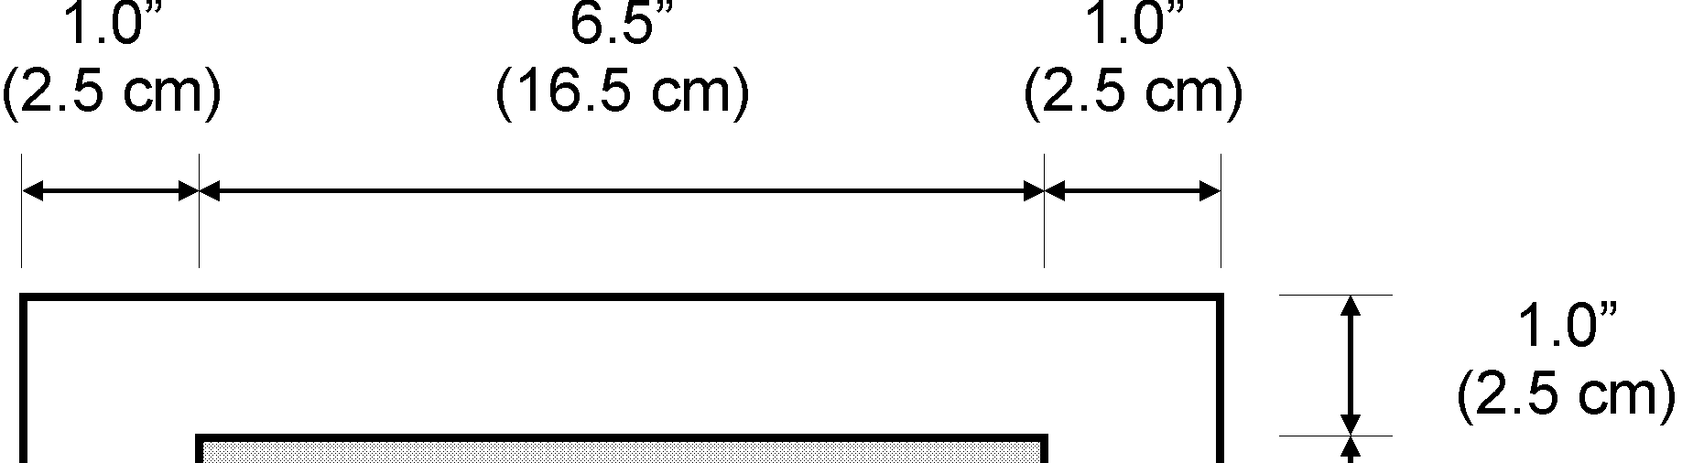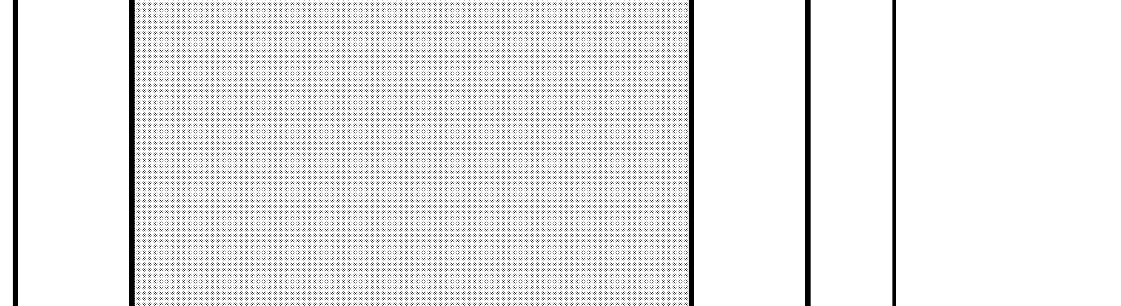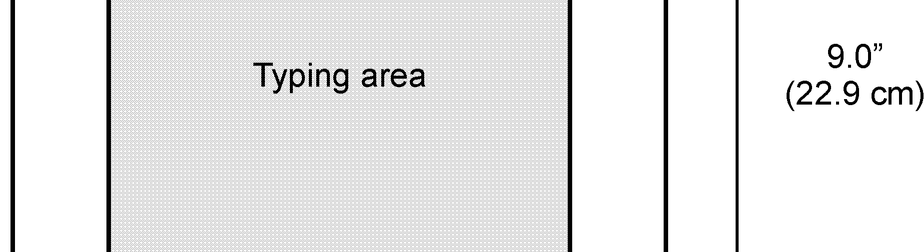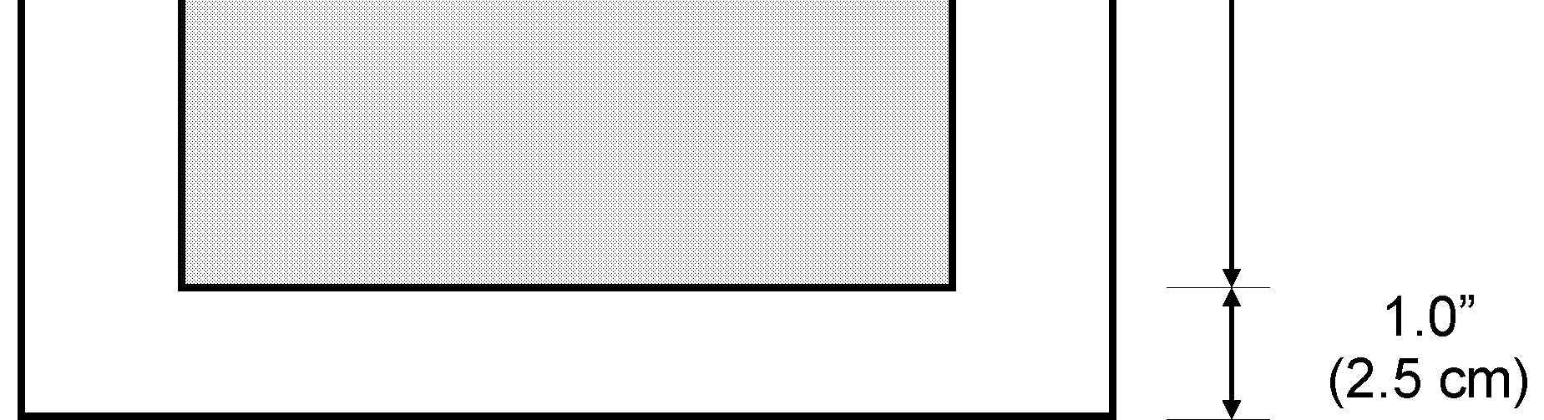

**Figure 1.** Manuscript layout using letter-sized paper

1. All mathematical symbols and equations should be typed using the Georgia or Symbol fonts. Equations should be centered between the margins and sequentially numbered throughout the text, with the number in parenthesis at the right margin on the same line as the equation. Leave one blank line before and after the equation (see example below).

*A*=π*r*2 (1)

1. Do not include typed page numbers, headers, or footers anywhere in the manuscript. Do not put anything in the 1-inch margins of the paper.
2. All references should appear together at the end of the manuscript under the main section heading “References.” List references alphabetically by the last name of the first author, using the Georgia 11 pt. font, left justified, with a hanging indent of 0.3” and without any blank lines in between.

* Invert all authors’ names, with their last names appearing first, followed by a comma and their initials (if more than one initial, separate initials with periods but no spaces).
* When there are two authors, separate their names with the word “and” with no comma.
* When there are three or more authors, separate their names with a comma and the word “and” before the last author’s name.
* When there are two or more references by the same author(s), list them in chronological order from the earliest to the latest.
* When there is more than one reference by the same author from the same year, they can be distinguished by adding a character suffix to the year of publication—such as 1996a—starting with “a” and continuing in alphabetic order.

Titles of referenced books and journals are capitalized; titles of referenced papers are in sentence case (capitalize the first word and proper nouns) and in quotation marks (see reference examples in the template).

All references must be cited in the text by the author’s name and the year of publication. Both the author’s name and date are enclosed in parentheses, separated by a space, as in (Henderson 1966); however, if the author’s name is part of the sentence, it is followed by the year in parentheses, as in “Henderson (1966) suggests.” If there are two authors for a single reference, include both authors’ names in the text citation (Meyer-Peter and Müller 1982); if there are three or more authors for a single reference, cite the first authors’ name followed by et al. (Parker et al. 1982). If there are multiple references cited together, separate them with a semicolon (Henderson 1966; Parker et al. 1982).

**Template**

A template for formatting technical papers is provided on the next page.

## Title (Verdana 16 pt.)

**Author #1 First and Last Name**,Title, Agency, City, State, e-mail (Georgia 11 pt.)

**Author #2 First and Last Name**,Title, Agency, City, State, e-mail (Georgia 11 pt.)

**Abstract (Verdana 14 pt.)**

After a blank line, the body of the abstract follows and is left-justified. (Georgia 11 pt.)

## Introduction (Verdana 14 pt.)

**First-Level Subheadings (Verdana 12 pt.)**

After a blank line, the body text follows and is left-justified. (Georgia 11 pt.)

Paragraphs under subheadings are separated by one blank line, with no indentations, and are left-justified.

**Second-Level Subheadings (Verdana 11 pt.):**Body immediately follows a colon and is left-justified. (Georgia 11 pt.)

## Other Major Headings (Verdana 14 pt.)

**First-Level Subheadings (Verdana 12 pt.)**

After a blank line, the body text follows and is left-justified. (Georgia 11 pt.)

Paragraphs under subheadings are separated by one blank line, with no indentations, and are left-justified.

**Second-Level Subheadings (Verdana 11 pt.):**Body immediately follows a colon and is left-justified. (Georgia 11 pt.)

Tables are referenced in the text (Table 1).

**Table 1.** Title is centered above table, with one blank line

of separation (Georgia 9 pt.)

|  |  |  |  |  |
| --- | --- | --- | --- | --- |
|  |  |  |  |  |
|  |  |  |  |  |
|  |  |  |  |  |

Figures are referenced in the text (Figure 1).



**Figure 1.** Caption is centered below figure, with one blank line of separation (Georgia 9 pt.)

## References (Verdana 14 pt.)

Henderson, F.M. 1966. Open Channel Flow. Macmillan Publishing Company, Inc., New York.

Meyer-Peter, E. and Müller, R. 1948. “Formulas for bed-load transport,” Proc. 2nd Meeting of the IAHR, Stockholm, Sweden, pp 39–64.

Parker, G., Klingeman, P.C., and McLean, D.G. 1982. “Bedload and size distribution in paved gravel-bed streams,” Journal of Hydraulic Engineering, ASCE, 108(4):544–571. (Georgia 11 pt.)